Create More Possible
For more information can visit our official website：www.feiyu-tech.com
Some functions may have change due to product firmware updates and changes.
Users can get the latest instructions from the official website.
Installation manual

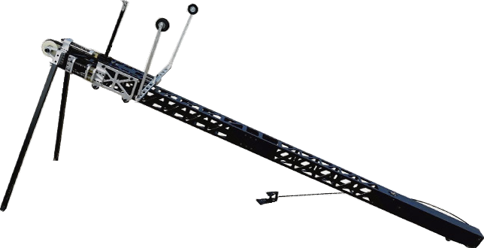

Dear customers,
Quick Start Guide before using this product.

Introduction
TS-2 Catapult is designed for small size UAV which weight is between 1.5Kg – 5Kg.It has the advantage of large stretch , high stability and strength . TS-2 Catapult supports most of the flying wing layout plane , and it also can used by regular plane after changing the ejection hook .

Attention
- This instruction also can use for TS-2 Small Size Catapult.
- The bearing range of the Catapult is 1.5Kg – 5Kg.
- When the plane is not installed, please do not eject the catapult . It will decrease the service life.
- Place the Catapult at an empty ground and there is no barrier in front of it.
- Check the Catapult carefully after every use.
- Irrelevant personnel can not stand near the Catapult while using.

Disclaimer
● Prohibit any user for any illegal purpose . Users will be responsible for all behaviors of purchase and use products.
● Our company assumes no liability for any risks related to or resulting from the debug and use of this product
(Including the direct , indirect or third-party losses ).
● For any unknown sources of using , we will not be at any services.
● You can get the latest user manual from the official website : www.feiyu-tech.com
● Feiyu Tech reserves the right to amend this manual and the terms and conditions of use the product at any time.
● This Agreement comes into effect automatically when the user purchases the product

SI TS-2 Catapult Parts Info S

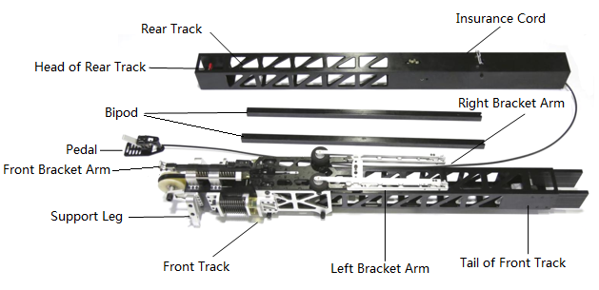

SII TS-2 Catapult Installation Instruction S

S1SSConnect Front Rail with Rear Rail
Connect the Head of Rear Rail with the Tail of Front Rail，and lock the buckle.
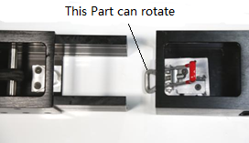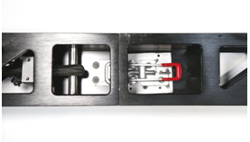
SAttentionS

- If the buckle can not be locked , you can properly rotate the buckle to adjust the tightness of it.
- Please make sure the connection of Front Rail and Rear Rail are fastened.

S2SSAssembley the Bipod
Assemble the Bipod to the Support Leg , and tighten the screws.
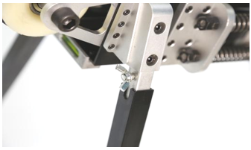

S3SSExpand the Bracket
Disassemble the screws of the transverse brackets . Expand the transverse brackets and tighten the screws.
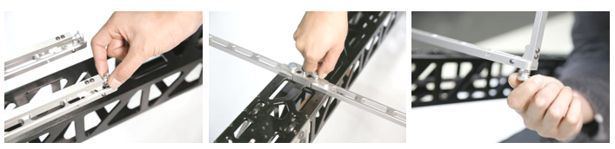

S4SSPush the catapult to the launch position
Hold the transverse bracket (Not front bracket) and push the catapult to bottom . Press on the button as shown，and then erect the front bracket. Finally hang up the insurance cord.
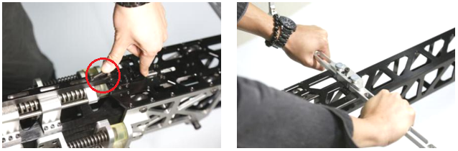
S5SSInstall the plane
Press the striker and put down the front bracket by about 15° , then install the plane on the front bracket .
( Make sure the front bracket has locked the plane )
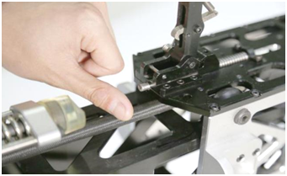
SAttentionS

If you want to use other model of planes , you should assemble the Ejection hook by yourself . The Ejection hook should be assembled in front of the center of gravity of the plane.

S6SSAdjust the plane and catapult
Adjust the wings to horizontal，the axis of the fuselage is parallel to the catapult track . Then adjust the catapult’s ejection direction against the wind direction and make sure there is no barrier in the launching direction .
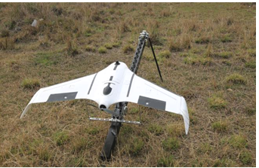
SAttentionS
Depend on the model of the planes , you can adjust the slant angle of the catapult. ( Default is 15° )
S7SSTake off
Release the insurance cord after everything is ok . Step on the pedal , and then the plane will be ejected out.
